Naveen Bonala Aws S3

1. Create s3 bucket and upload some objects to s3.

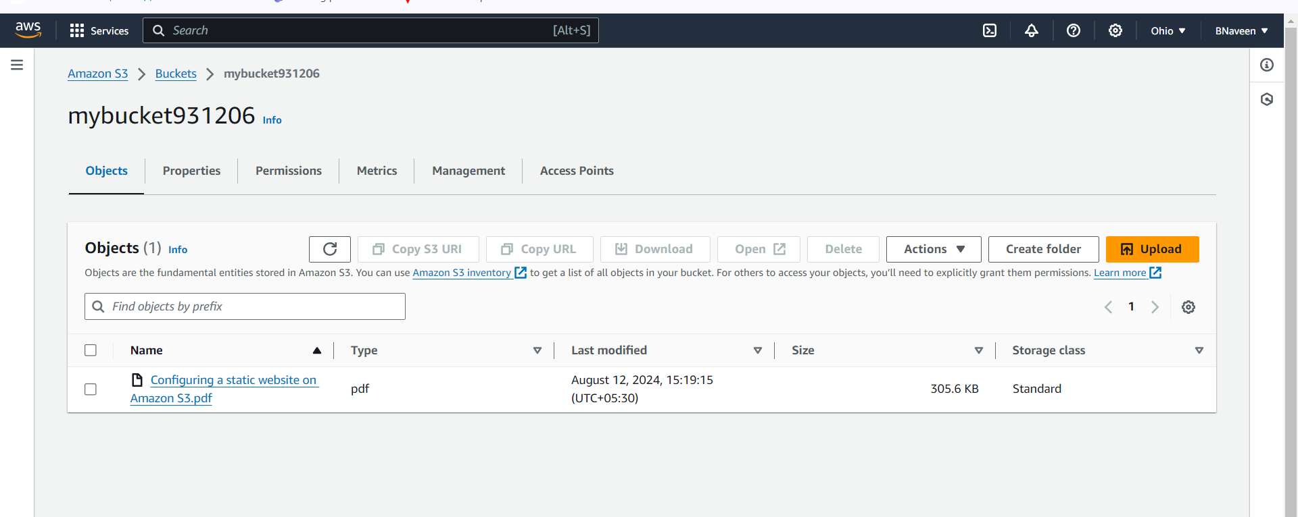

1. Deploy static website in s3 bucket.

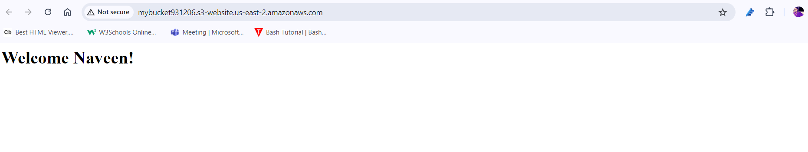

1. Enable cross region replication on s3 buckets.

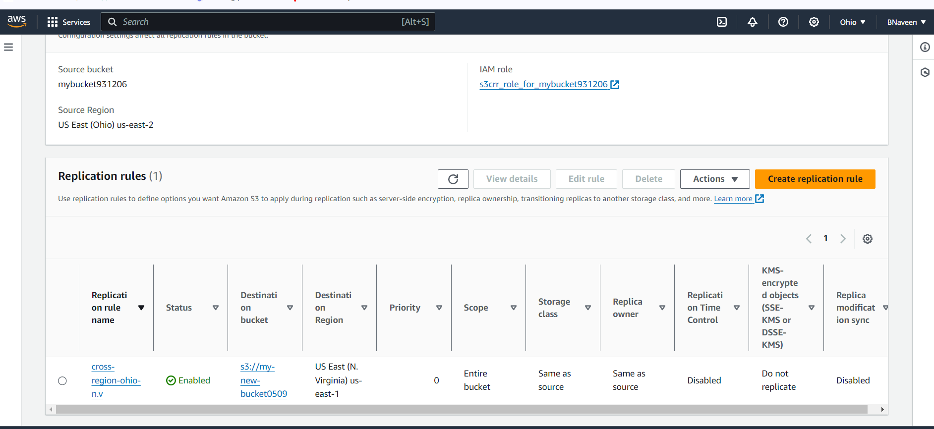

1. Configure bucket policy,only Admin user can see the objects of s3 bucket.

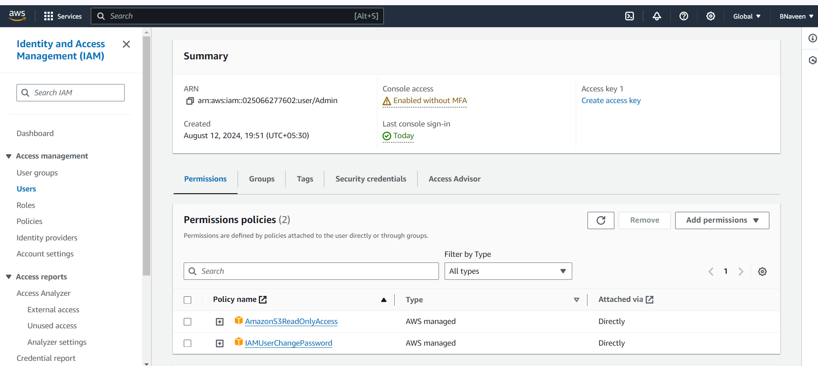

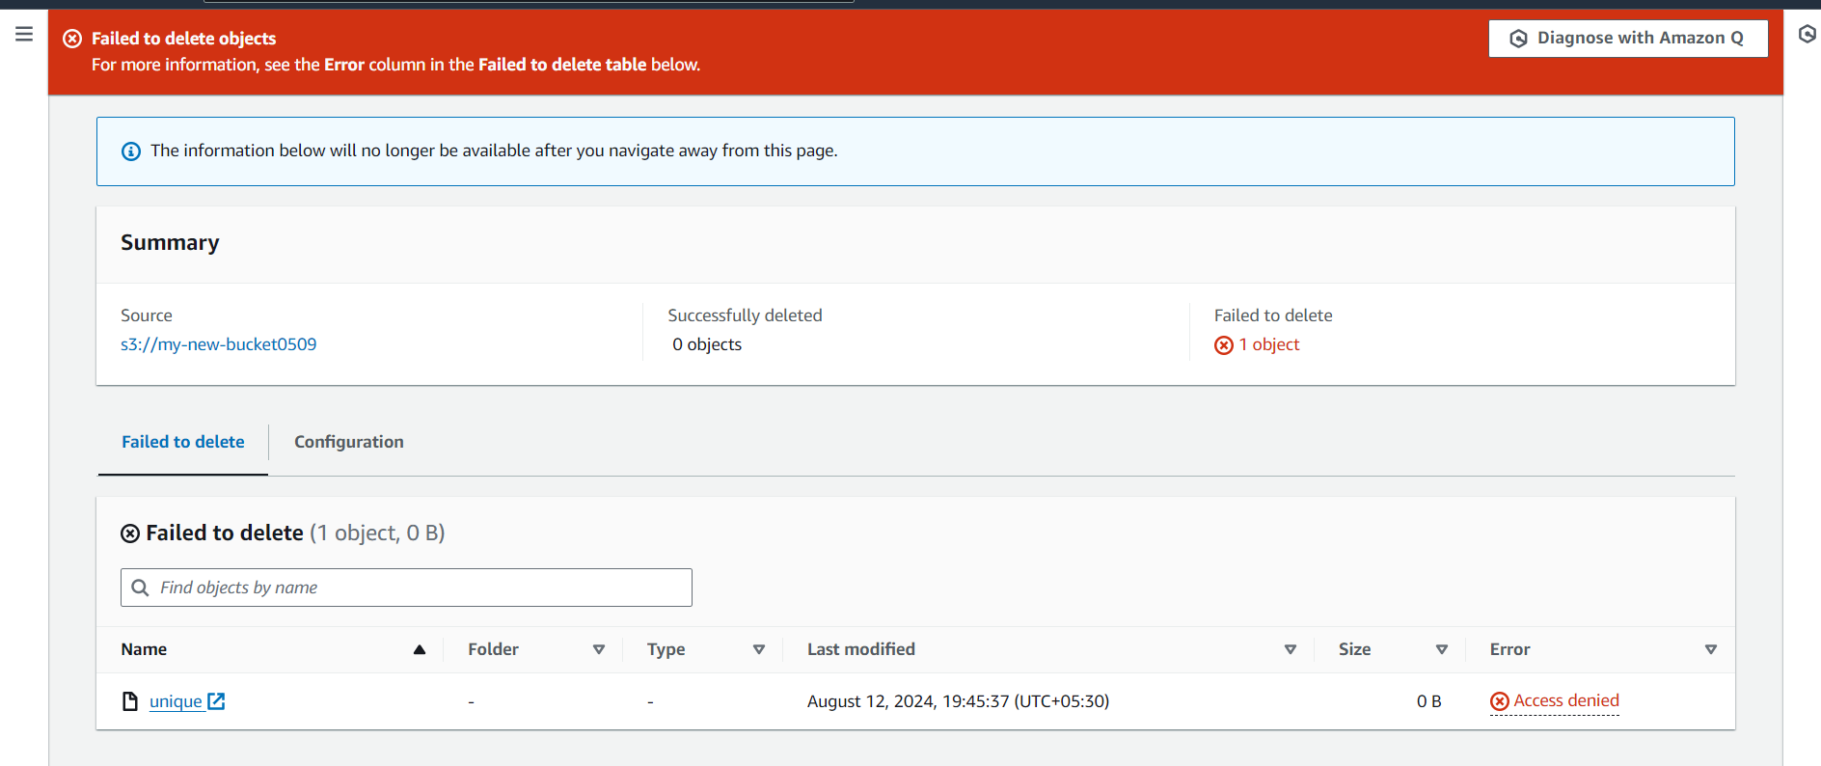

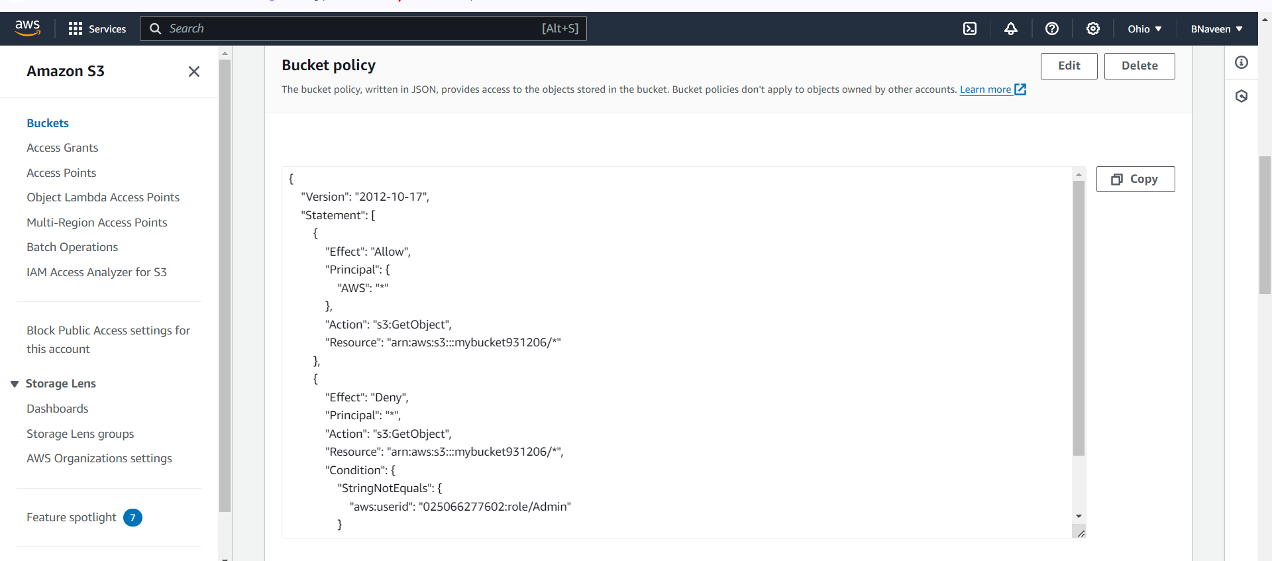

1. Setup lifecycle policies to automatically transition or delete objects based on specific criteria.

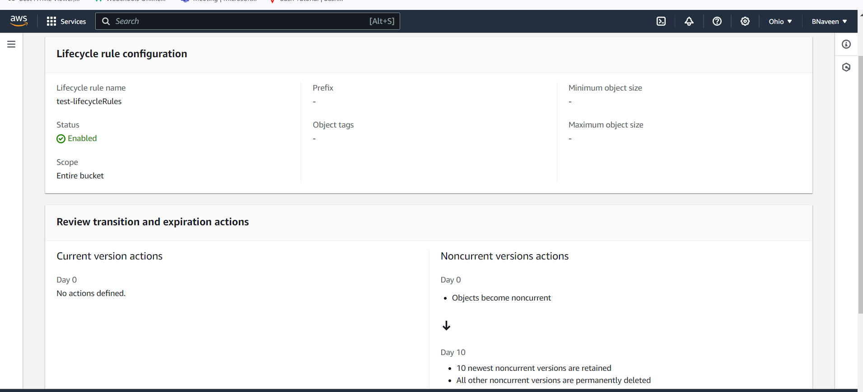

1. Push some objects in s3 using AWS CLI.

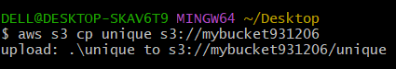

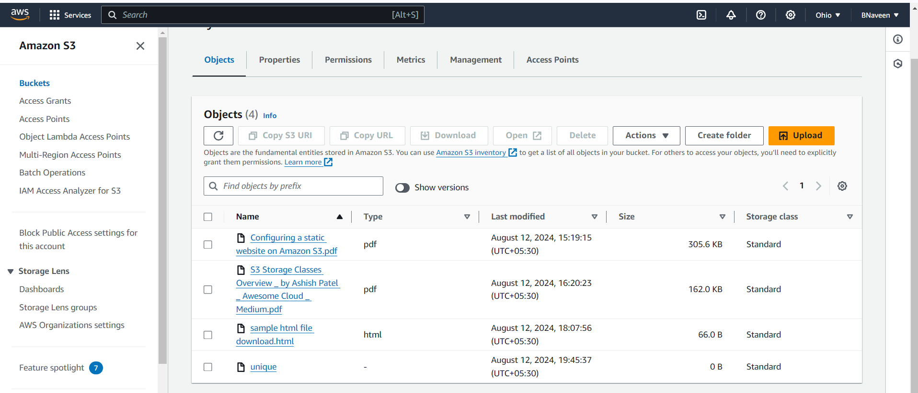

1. Write a bash script to create s3 bucket.

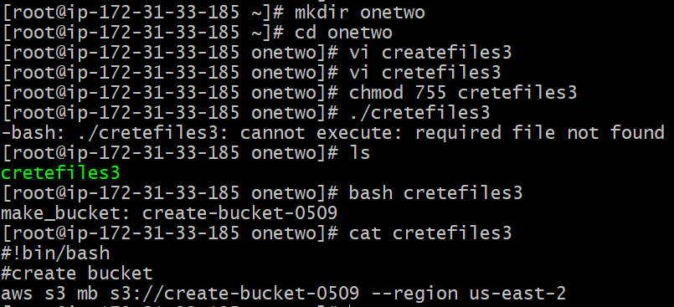

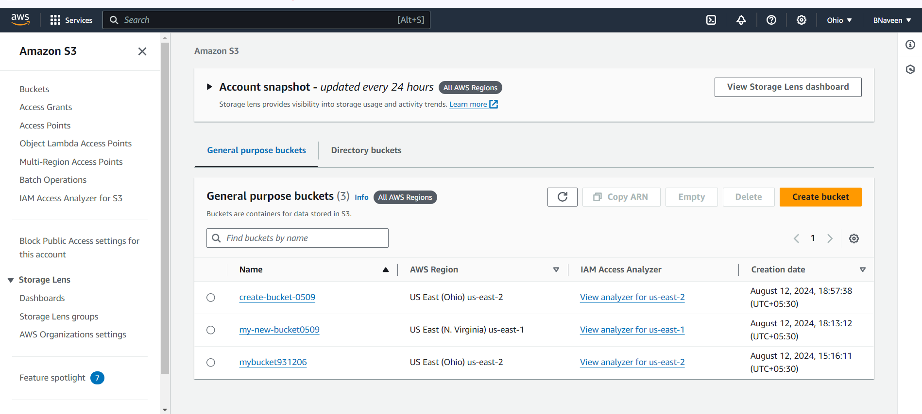

1. Upload one 1 gb of file to s3 using cli.

